**Schwitters, Kurt (1887-1948)**

**SUMMARY**

Kurt Schwitters is most commonly associated with Dada, but his relationship to that movement’s aesthetic, political, and philosophical rebellion was ambivalent. Though he was friends with and participated in shows with Berlin Dadaists, he never formally became a member of their group. Schwitters was also involved with the Expressionist gallery and magazine, *Der Sturm*, and Dada purists disdained Expressionism, with its focus on the personal rather than the political*,* the dominant concern of other German Dadaists such as George Gros and Richard Huelsenbeck. The formalist aspect of much of Schwitters’ work also separated his work from Dada “anti-art.”

Nevertheless, Schwitters is generally regarded as the greatest collage artist of the twentieth century. He named his particular style of collage, which often incorporated three dimensional as well as two-dimensional elements, Merz*.* Merzbecame a tag prefix for all his works, which included poetry, music, and architecture, as well as visual art.

After Schwitters’ art was included in the Nazi’s “Degenerate Art” exhibition, he escaped, first to Norway and then to England, where he continued to be artistically active until his death in 1948. Schwitters’ Merz aesthetics has been a major influence on avant-garde art throughout the twentieth and early twenty-first centuries.

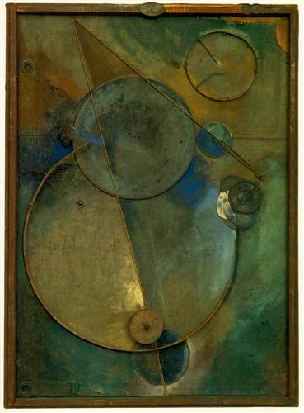

Kurt Schwitters, *Revolving* (1919). Assemblage, 122.7 x 88.7 cm. Museum of Modern Art, New York.

<http://www.wikiart.org/en/kurt-schwitters/revolving-1919>

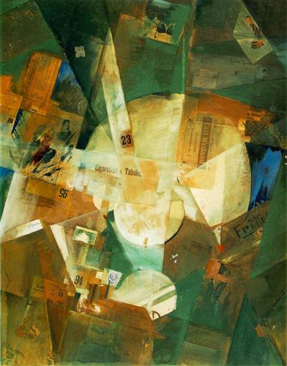

Kurt Schwitters, *Picture with Light Center* (1919). Collage, 84.5 x 65.7 cm. Museum of Modern Art, New York.

<http://www.wikiart.org/en/kurt-schwitters/picture-with-light-center-1919>

**MAIN ENTRY**

Kurt Schwitters (born Herman Edward Karl Julius Schwitters) attended the School of Arts and Crafts in Hanover, where he was born, and then the Dresden Academy. He worked as a draftsman and served as a clerical officer during World War I. Because he suffered from epileptic seizures, he was not drafted until late in the war, and he was released early because of the same condition. Early in his career he worked in Post-Impressionist, Expressionist, and Cubist styles. He exhibited in the Expressionist Der Sturm gallery in Berlin and published his writings in the periodical of the same name*.* In 1919 he met Dadaists Raoul Hausmann, Hannah Höch, Richard Huelsenbeck, and Hans Arp. Arp, especially, was a significant influence on Schwitters’ development of Merz. However, because of his Expressionist connections and artistic formalism, Schwitters never formally became a member of the Berlin Dada group. Huelsenbeck, one of the original founders of Dada in Zurich, called Schwitters ‘the Caspar David Friedrich of the Dadaist Revolution.’ Because Huelsenbeck disdained any form of romantic or Expressionist art, this cannot be regarded as a compliment.

In 1919 Schwitters made his first Merzcollages. Merz was a putatively nonsense syllable, taken from part of a printed word embedded in one of his early collages: “*Kommerz.”* In this respect it was like the name *Dada* itself, which, according to Huelsenbeck, was chosen at random from a French-German dictionary. Merzis an early form of appropriation and pastiche, an art pasted together from valueless, abject elements. Thus the term also suggests the French word, *merde* (i.e., shit)*.* Merz is an art made out of *merde.* But because Schwitters made careful choices regarding the color, shape, and arrangement of the pieces of *merde* he used, his *merzbilder* are more related to the formalism of Cubist collage than to Dada anti-art such as the readymades of Marcel Duchamp or the chance constructions of Arp. In spite of their Dada connection with junk, they were also akin to movements like De Stijl and Constructivism, movements often discussed in his journal, *Merz,* which he published between 1923 and 1932.

There was also a socially engaged, if not narrowly political, aspect to Merz*.* For Schwitters, the Merz aesthetic was associated with (among other things) the rebuilding of Germany after the devastation of the war. Building a new society out of the ruins of the old one was like making something elevated (like art) out of something low (like shit).

Schwitters became a successful businessman, heading his own advertising agency, travelling, and helping develop and propogate modern forms of typography. As with other aspects of his career, success as an entrepreneur working within a modern capitalist system and popularizing modernistic aesthetic ideas within that system were not in the spirit of the political and aesthetic rebellion that defined Dada.

During the same period in which *Merz* was published, Schwitters began working on his *Merzbau* (Merz Building) which grew to occupy much of his family house and studio in Hannover. The *Merzbau* was a three dimensional *merzbild,* anassemblage of interconnected enclosures that contained a great variety of objects and substances with autobiographical associations (including hair and bottled urine). It also incorporated work by other artists associated with Dada, including Hannah Höch, Raoul Hausmann and Sophie Taeuber. In 1943 the Hannover *Merzbau* was destroyed during an allied bombing.

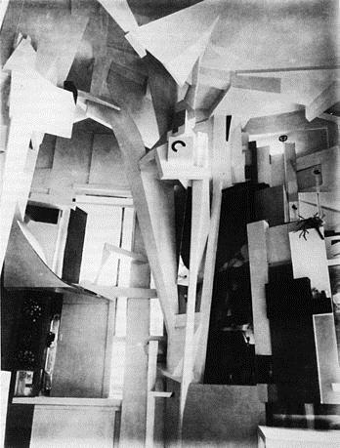

Kurt Schwitters, *Merzbau* (1923-1937). Installation (destroyed in World War II).

<http://www.wikiart.org/en/kurt-schwitters/revolving-1919#supersized-artistPaintings-284169>

Schwitters’ merz poetry was constructed from randomly picked bits of conversation or phrases from print sources—a process analogous to the found and reconstructed method of his *merzbilder.* His poem, ‘An Anna Blume’ (published in *Der Sturm* in 1919), a nonsensical parody of love poems, is a classic of Dada poetry. His sound art, constructed of bits of conversation, song fragments, and other found materials, was another counterpart to his *merzbilder*. It can be seen as an antecedent to *musique concrete* and (because the score leaves much to the decisions of the performer) the aleatory compositions of John Cage. The following is an excerpt of Schwitters’ own 1922 translation of ‘An Anna Blume,’ retitled as ‘To Eve Blossom,’

Who art thou, uncounted woman, Thou art, art thou?   
People say, thou werst,   
Let them say, they don't know what they are talking about.   
Thou wearest thine hat on thy feet, and wanderest on thine hands,   
On thine hands thou wanderest   
Hallo, thy red dress, sawn into white folds,   
Red I love Eve Blossom, red I love thine,   
Thou thee thee thine, I thine, thou mine, we?   
That (by the way) belongs to the cold glow!   
Eve Blossom, red Eve Blossom what do people say?

<http://www.costis.org/x/schwitters/eve.htm>

One of Schwitters’ most important works was a musical/poetic piece, ‘Ursonate’(‘*Ur* *Sonata*,’ 1922-1932). *Ursonate* is a nonverbal voice art form, consisting of nonsense syllables, but modeled after the form of a classical sonata. It is declaimed and sung, producing a primitive, “ur” voice art, which recaptures the expressive possibilities of the voice, utilizing tempo, pitch, and dynamics, as an infant might vocalize, without recourse to language.

**Ursonate Score:**

<http://www.merzmail.net/ursonatepdf.pdf>

**Ursonate, Recording (performed by Ernst Schwitters)**

<http://writing.upenn.edu/pennsound/x/Schwitters.html>

Schwitters later joined and wrote for the publication of the Paris-based Abstraction-Création group, which also published photos of his *Merzbau.* Abstraction-Création was an association of diverse artists connected with various movements (Expressionism, neo-plasticism, Dada), and united primarily by their commitment to non-objectivity, in opposition to Surrealism.

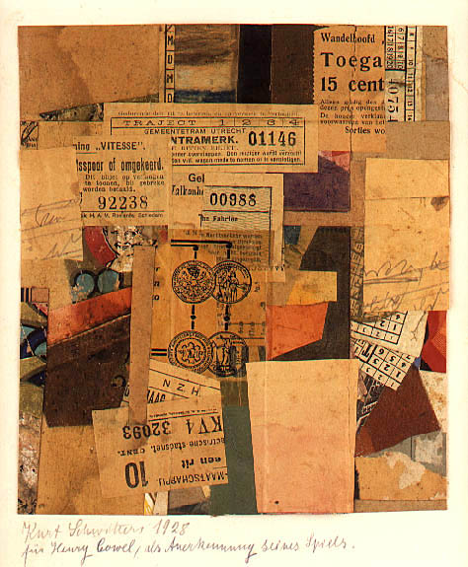

Kurt Schwitters, *Untitled* (1928), collage, 184 X 171 cm. Collection Jaspar Johns.

<http://gridrow.tumblr.com/post/159247954/kurt-schwitters-1887-1948-untitled-1928>

In 1937 Schwitters’ art was included in the Nazi’s ‘Degenerate Art’ exhibition, which consisted of confiscated works regarded as examples of the cultural degeneration of modern art. Like other artists, whose careers as well as their wellbeing were seriously jeopardized, Schwitters escaped, first to Norway, where he constructed a new *Merzbau,* and then to England, where he was interned for over a year. In England, Schwitters continued to be artistically active. Works such as *For Kate* (1947) and *En Morn* (1947)*,* anticipated the emergence of British and American Pop. That same year he began working on a third *Merzbau,* which remained unfinished when he died in 1948.

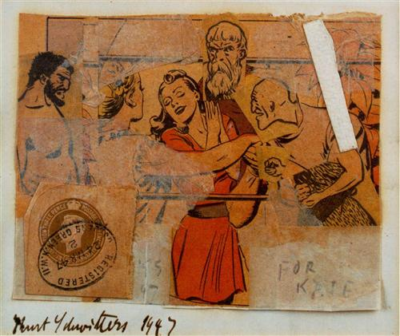

Kurt Schwitters, *For Kate* (1947). Collage, 9.8 x 13 cm. Private Collection.

<http://www.wikiart.org/en/kurt-schwitters/for-kate-1947>

Few avant-garde artists of the twentieth and twenty-first centuries have not been been influenced, directly or indirectly, by Schwitters’ art and his Merzaesthetics. His art, in various media, can be associated with earlier innovations, like Cubist collage and Duchamp’s readymades, as well as the later combines of Robert Rauschenberg, aleatory music, *musique-concrete,* Pop Art, installation art, appropriation, and postmodern *pastiche*.

**Further Reading**

Crossley, Barbara. *The Triumph of Kurt Schwitters*, Armitt Trust Ambleside, 2005,

Elderfield, John. *Kurt Schwitters.* Thames and Hudson, London 1985.

Humphries, Richard. “Kurt Schwitters,” Museum of Modern Art, “The Collection” (from Grove Art Online © 2009 Oxford University Press). <http://www.moma.org/collection/artist.php?artist_id=5293>

Luke, Megan R., *Kurt Schwitters: Space, Image, Exile*, Chicago: The University of Chicago Press, 2013.

McBride, Patrizia C. "The Game Of Meaning: Collage, Montage, And Parody In Kurt Schwitters' Merz." *Modernism/Modernity* 14.2 (2007): 249-272.

Rothenberg, Jerome and Pierre Joris (ed.) *Kurt Schwitters, poems, performance, pieces, proses, play poetics*, Temple University Press, Philadelphia 1993.

Webster, Gwendolen. *Kurt Merz Schwitters, a Biographical Study*, University of Wales Press 1997.